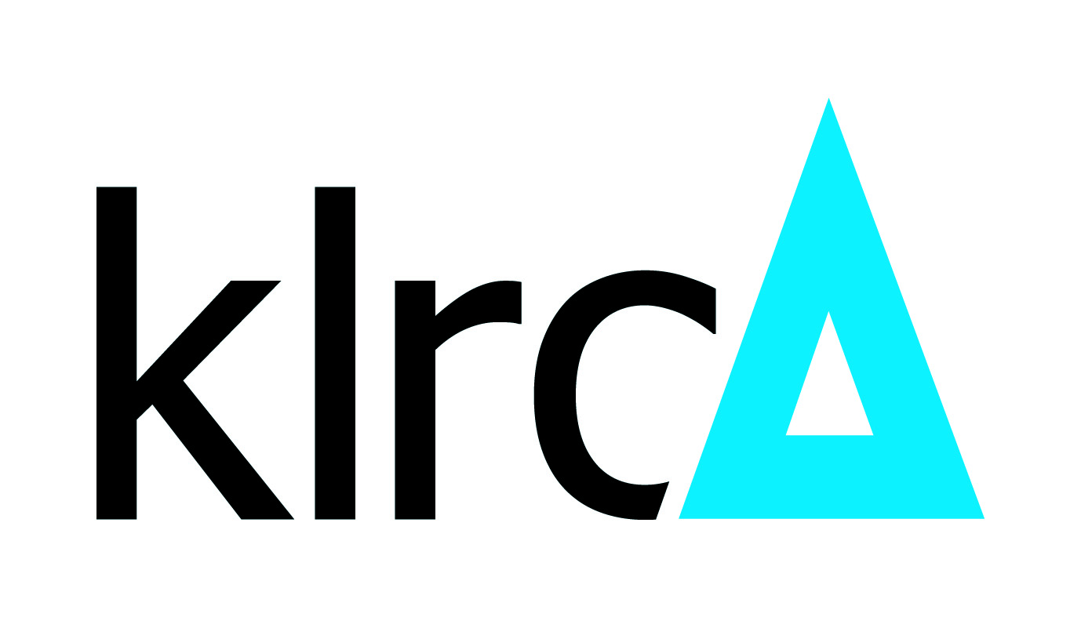
Regional Resolution Global Solution

(NOTE: In preparation for filing of forms, Parties are advised to refer to the .my DOMAIN REGISTRY’s (.my) Sensitive Domain Name Dispute Resolution Policy (SNDRP), the Rules of the SNDRP and the Supplemental Rules of the Regional Centre for Arbitration Kuala Lumpur.)

FORM D-SNDRP

WITHDRAWAL OF CASE [SPECIFY *BEFORE CHAIRMAN APPOINTMENT / BEFORE SUB-REFERENCE PANEL FORMATION / *AFTER SUB-REFERENCE PANEL FORMATION AND BEFORE SUB-REFERENCE PANEL DECISION]
(Rule 5.1, 7 & 15 Rules of the SNDRP)

- DETAILS OF THE CASE [Name to be listed in full]

CASE NUMBER:
DISPUTED DOMAIN NAME(S):
CASE ADMINISTRATOR:
PARTIES NAME:
- Complainant:
- Respondent:

  - WITHDRAWAL OF THE CASE [SPECIFY *BEFORE CHAIRMAN APPOINTMENT/ BEFORE SUB-REFERENCE PANEL FORMATION / *AFTER SUB-REFERENCE PANEL FORMATION AND BEFORE SUB-REFERENCE PANEL DECISION]

Kindly be informed that both Parties hereby agree to settle the dispute pursuant to the Rules of the .my DOMAIN REGISTRY’s (.my) Sensitive Domain Name Dispute Resolution Policy. A copy of the formal letter of withdrawal from the Complainant dated [please specify date]* attached herewith for your records.

Submitted by,

The Complainant

Signature:
Name:
Capacity:
Date:

*Note: Fees are non-refundable

