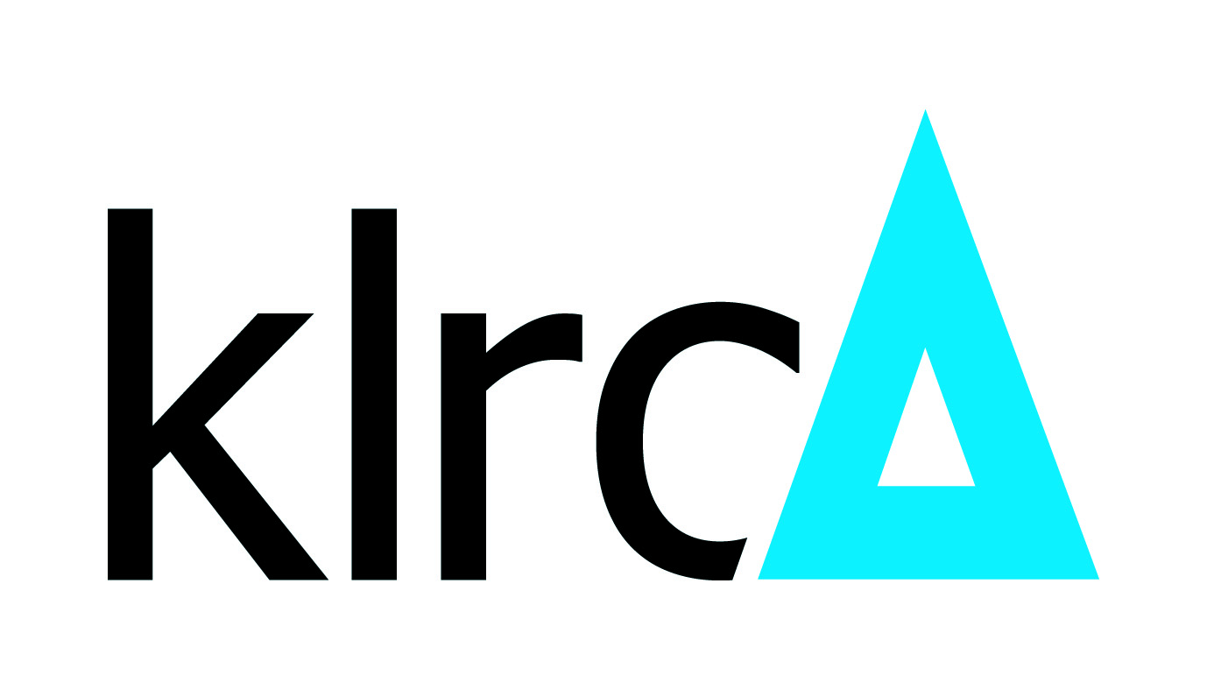
Regional Resolution Global Solution

(NOTE: In preparation for filing of forms, Parties are advised to refer to the .my DOMAIN REGISTRY’s (.my) Sensitive Domain Name Dispute Resolution Policy (SNDRP), the Rules of the SNDRP and the Supplemental Rules of the Regional Centre for Arbitration Kuala Lumpur.)

FORM C-SNDRP

Please use this form to request for extension of time to file a Response pursuant to the .my DOMAIN REGISTRY’s (.my) Sensitive Domain Name Dispute Resolution Policy (SNDRP), the Rules of the SNDRP, and the Supplemental Rules of the Regional Centre for Arbitration Kuala Lumpur.

REQUEST FOR EXTENSION OF TIME TO RESPOND TO COMPLAINT

- DETAILS OF THE CASE [Name to be listed in full]

CASE NUMBER:
DISPUTED DOMAIN NAME(S):
CASE ADMINISTRATOR:
PARTIES NAME:
- Complainant:
- Respondent:

  - REQUEST FOR EXTENSION OF TIME

Pursuant to Rule 6.5 of the Rules of the .my DOMAIN REGISTRY’s (.my) Sensitive Domain Name Dispute Resolution Policy (the Rules), the Respondent requests an extension of time for a period of______ days to respond to the Complaint based on the exceptional circumstances stated below:

[Explain the circumstances that the request for extension of time is based upon and attach relevant evidence in relation thereto.]

Submitted by,

Signature:
Name:
Capacity:
Date:

